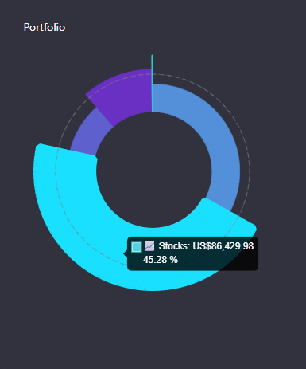
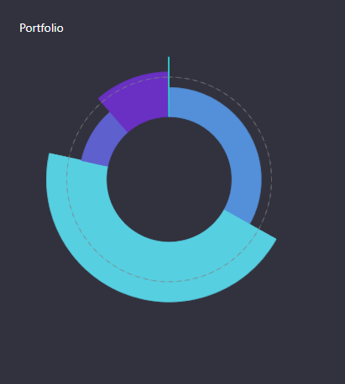

Table Dividing Into Type of Holding (e.g. Cash, Stocks, Funds, etc.):
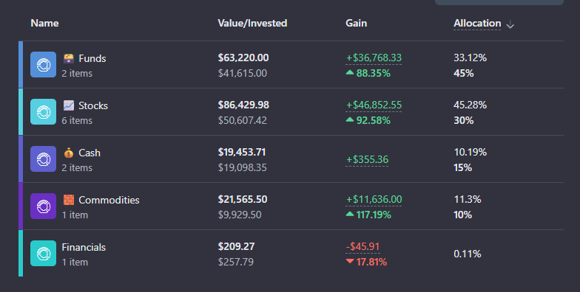

Holdings Table:

Clean Holdings Table Design:
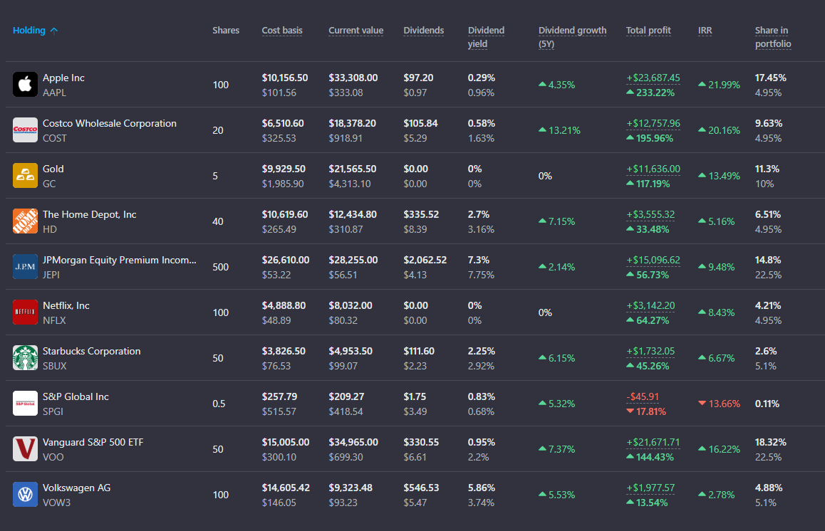

Clean Holdings Table Design 2:
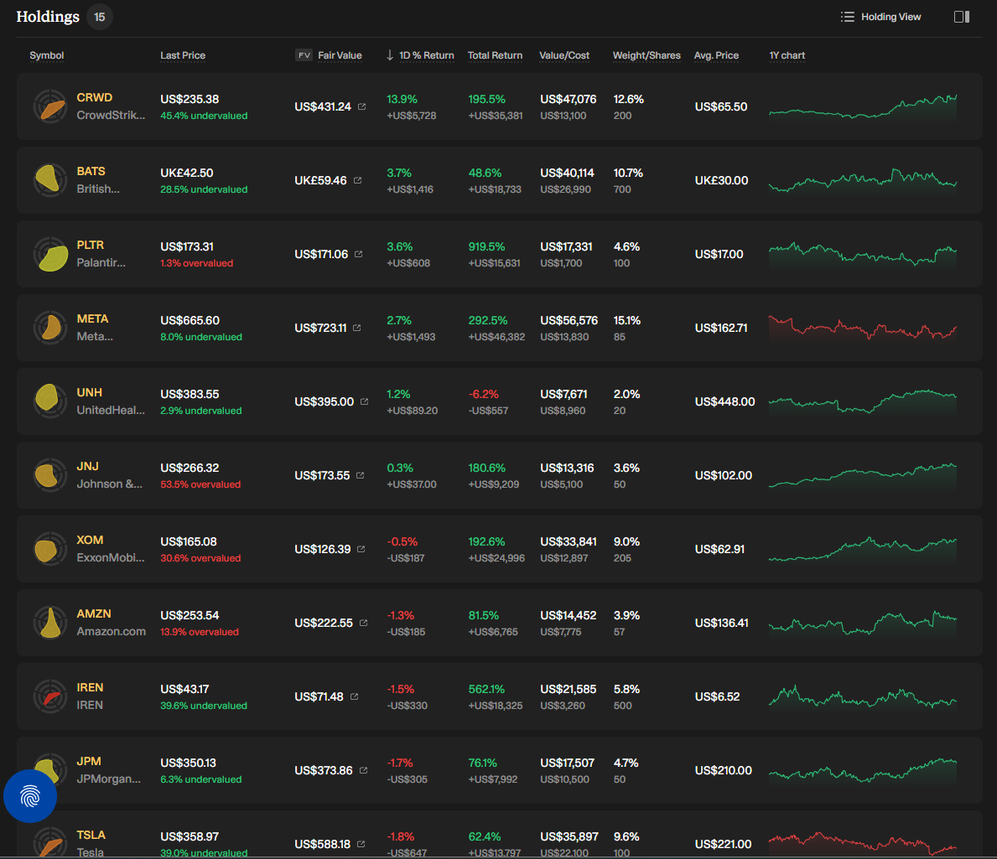
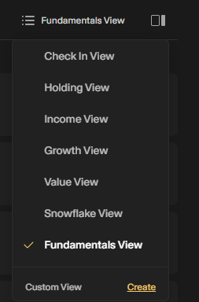
Holding View | Symbol | Last Price | FV Fair Value | 1D Return | Total Return | Value/Cost | Weight/Shares | Avg. Price | 1Y Chart
Income View | Symbol | Last Price | FV Fair Value | Div. Yield | Est. Ann. Income | Div. Score | Payout Ratio | Div. Growth | Future Div Yield
Growth View | Symbol | Last Price | FV Fair Value | 7D Return | 3M Return | Total Return | Future Score | Future E. Growth | Future ROE
Value View | Symbol | Last Price | FV Fair Value | Value Score | P/E Ratio | P/S Ratio | Debt to Equity | Health Score | ROCE
Snowflake View | Symbol | Last Price | FV Fair Value | Value/Cost | Value Score | Future Score | Past Score | Health Score | Dividend Score
Fundamentals View | Symbol | Last Price | FV Fair Value | Net Margin | Past E. Growth | Fut. E. Growth | Debt to Equity | ROCE | ROE

Click/Hover over a Holding, opens a Tab on the side with more info:
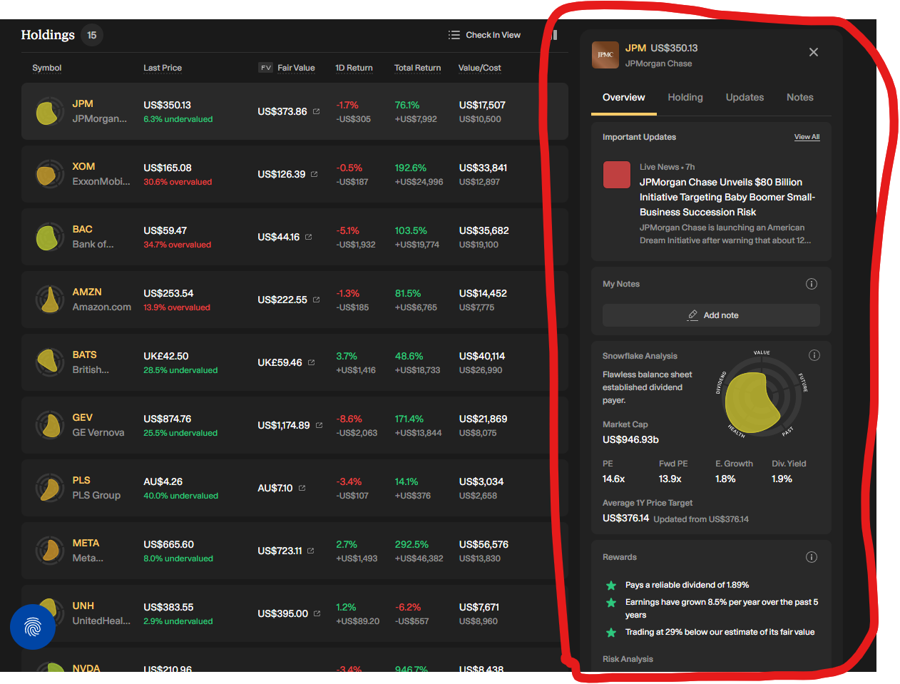
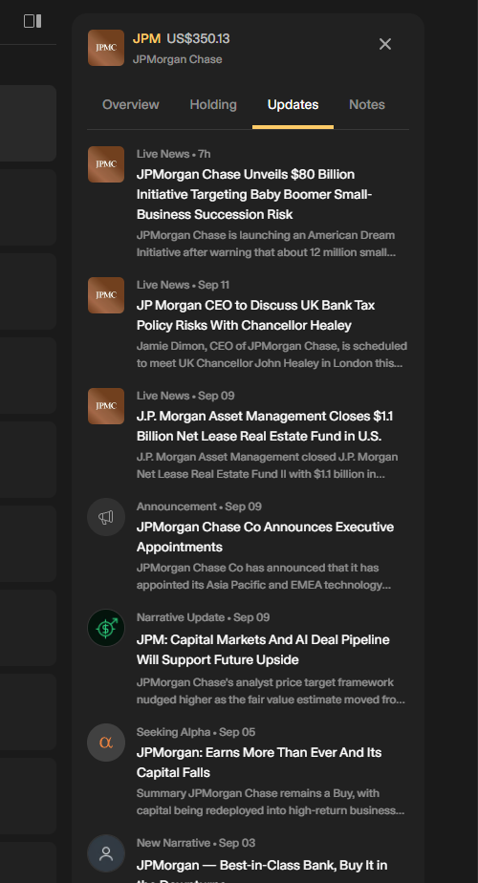

Highly Detailed Company Profiles (don’t know where it gets that info tho):
https://simplywall.st/stocks/us/banks/nyse-jpm/jpmorgan-chase
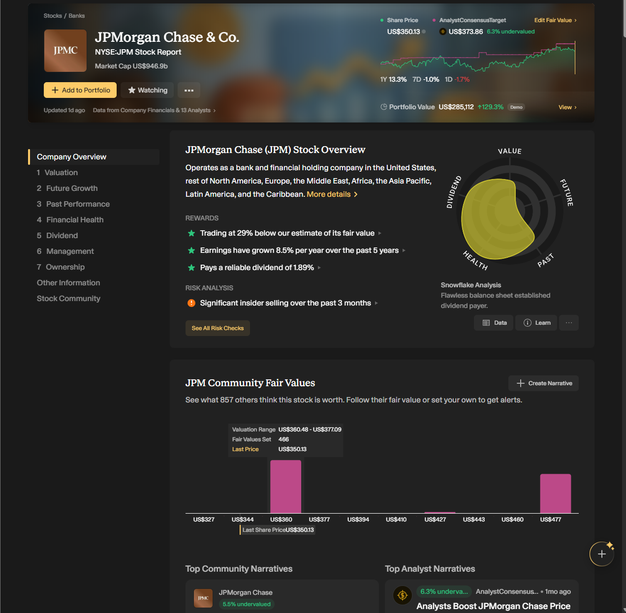
Clean Top Band Boxes (especially the total profit and daily profit one):
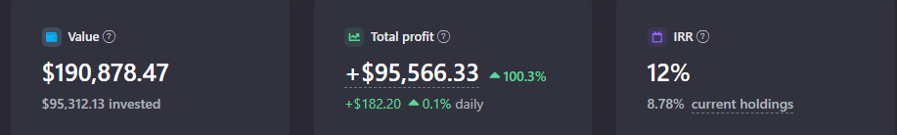

Portfolio Analysis Sub-Page / Diversification Sub-Page:
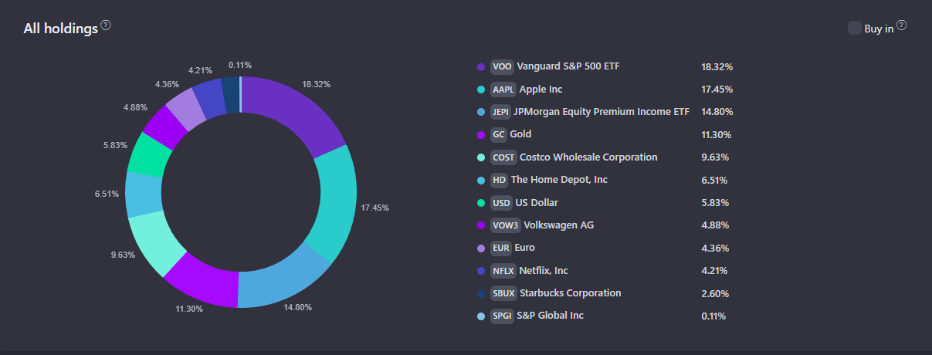
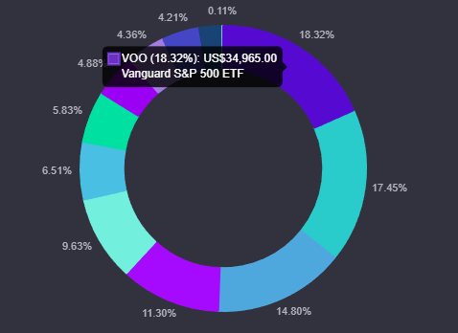
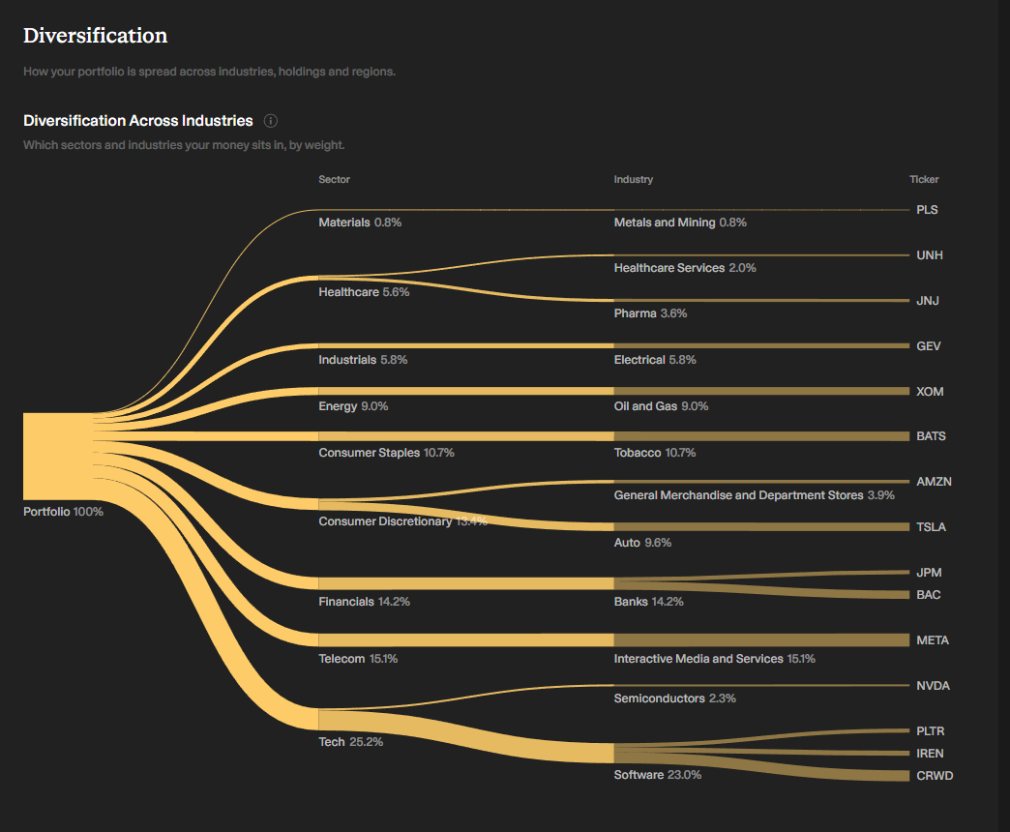
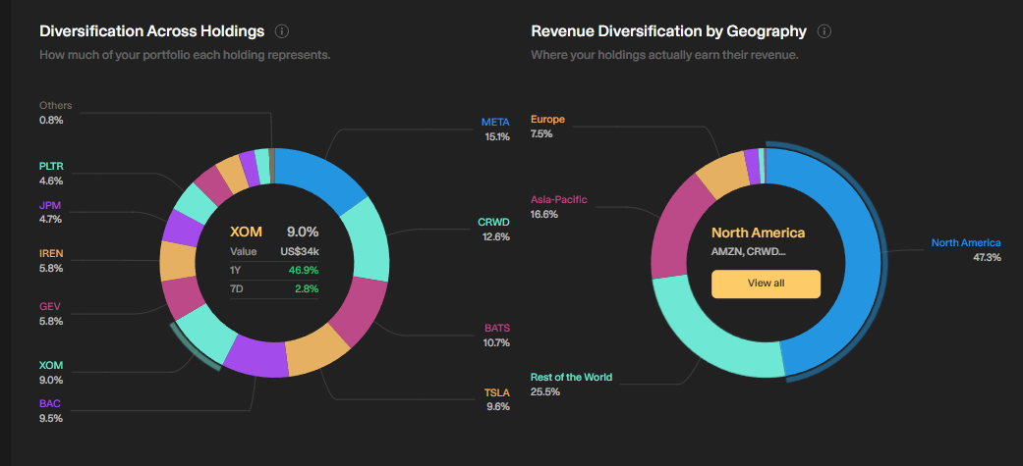
- Click on “View All” in Geography Pie Chart:
  - 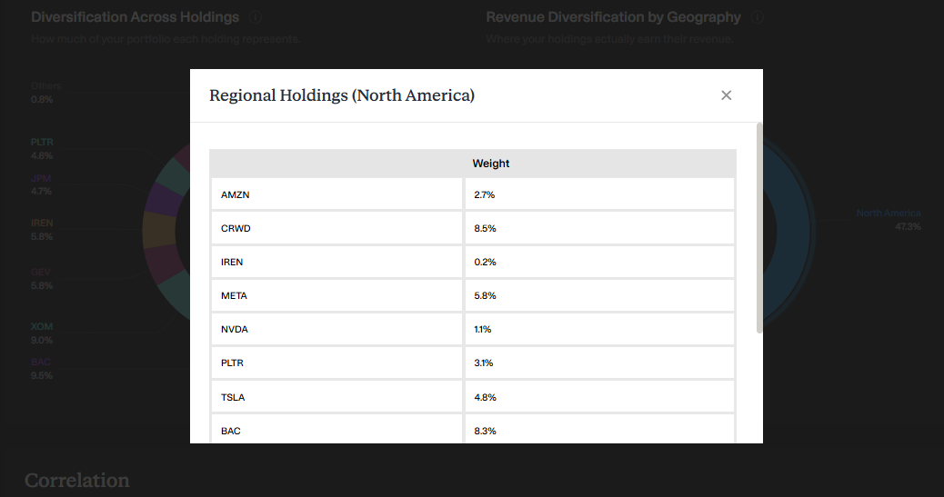

Correlation (potentially useful, at least the moves together, moves least together bit):
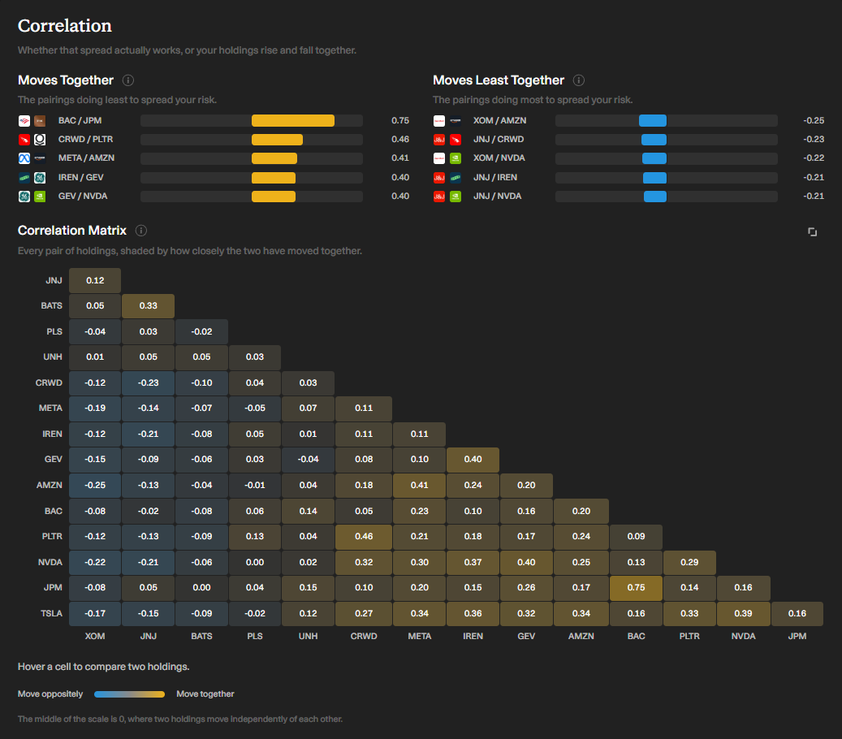

Pie Charts for the 4 following things: Sectors, Classes, Regions, Countries (don’t do currencies).

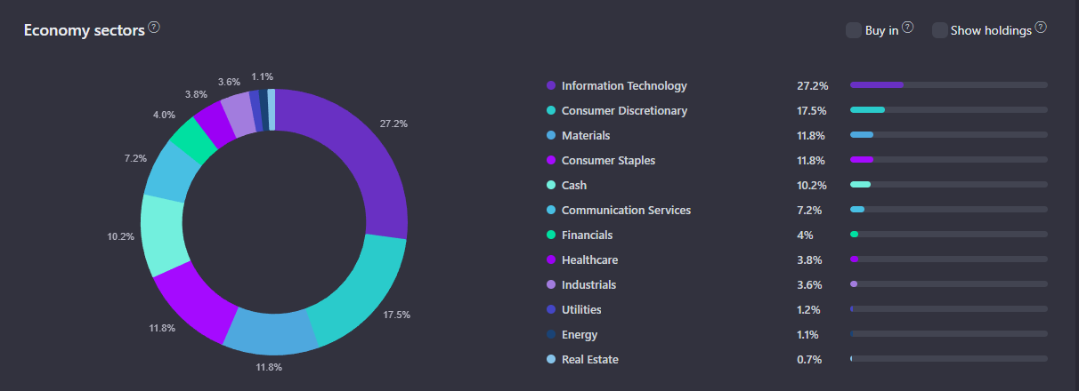
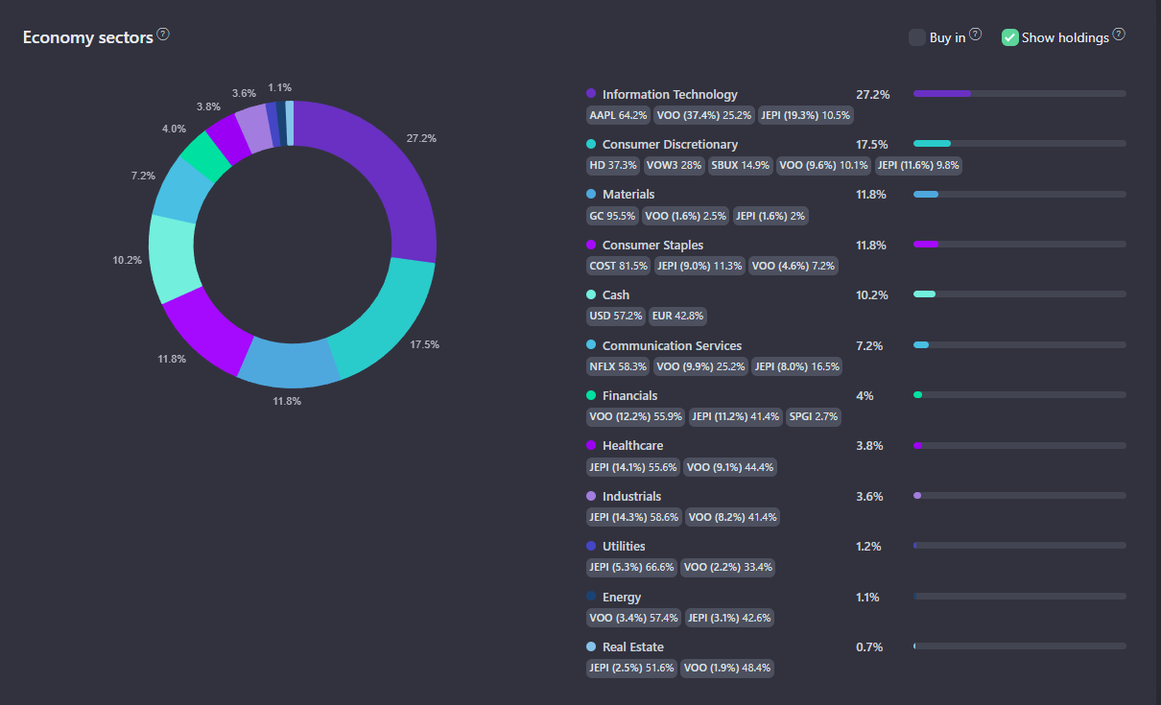
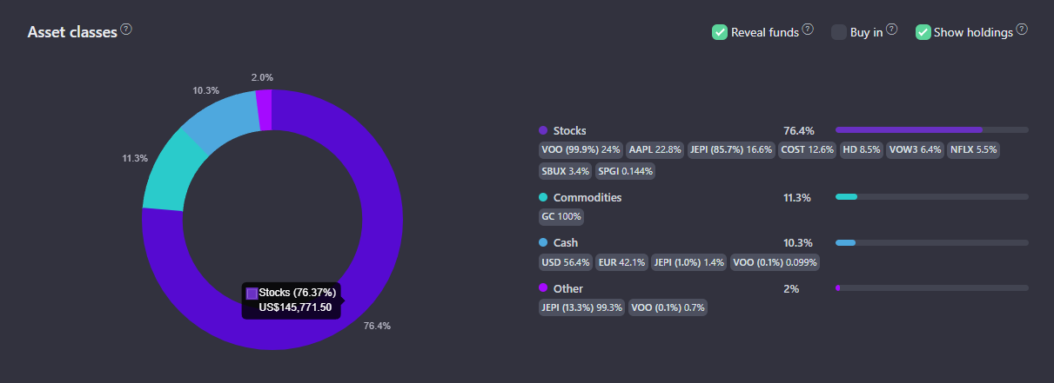
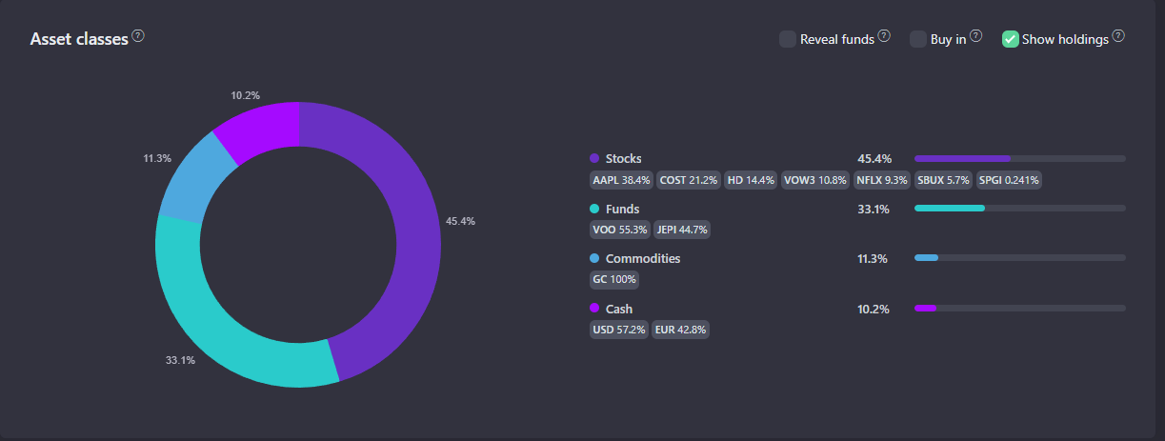
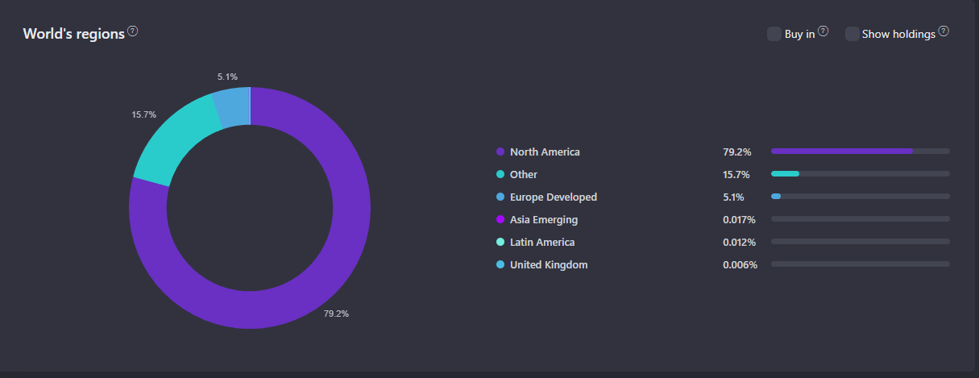
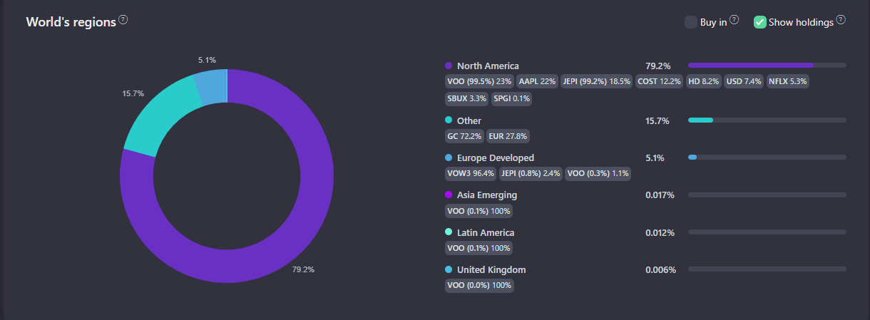
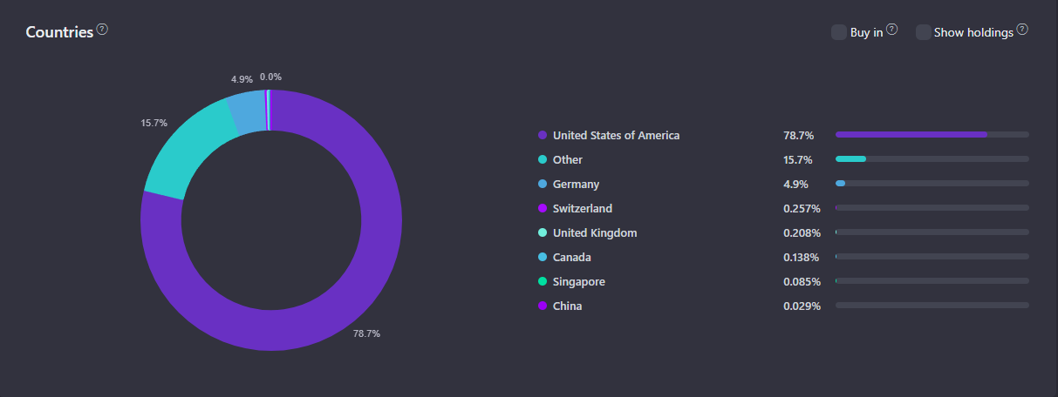
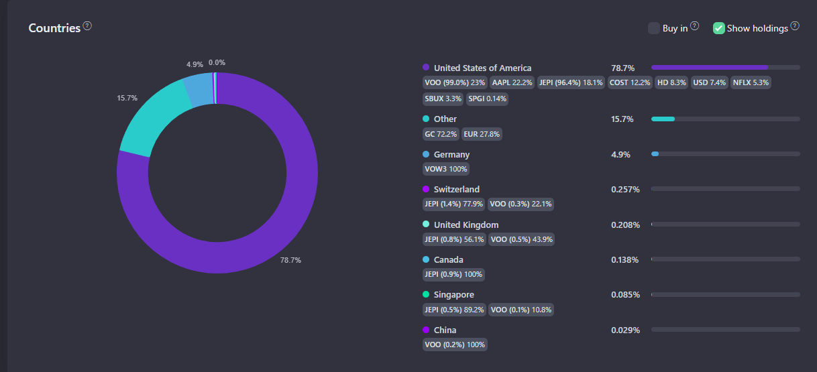
Average Annual Growth (with drop down to filter by Sectors, Classes, Regions, Countries):
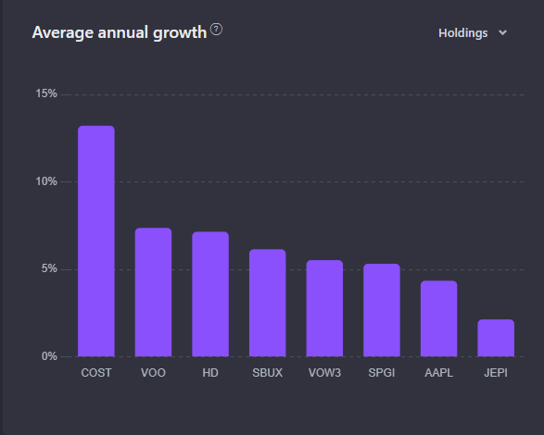
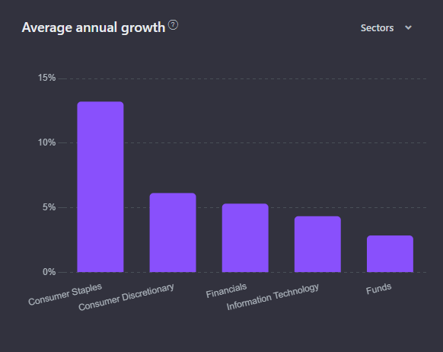

Portfolio Analysis – Scorecard: 5 Metrics – Value, Future, Past, Health, Dividend, each out of 6.
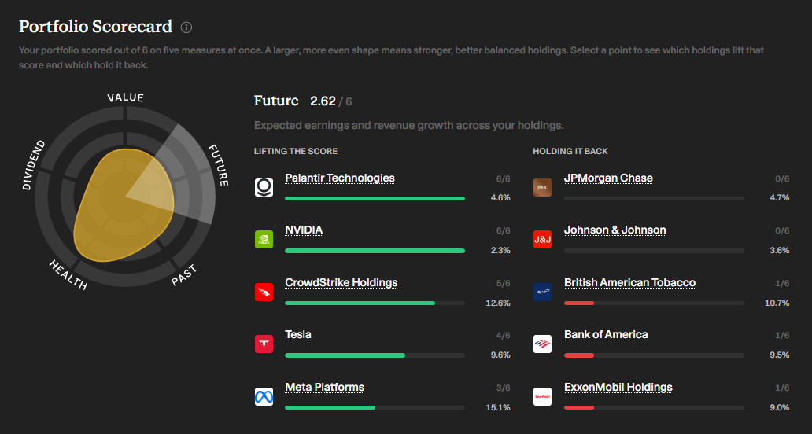
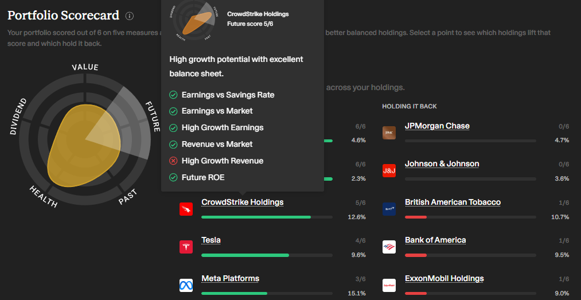

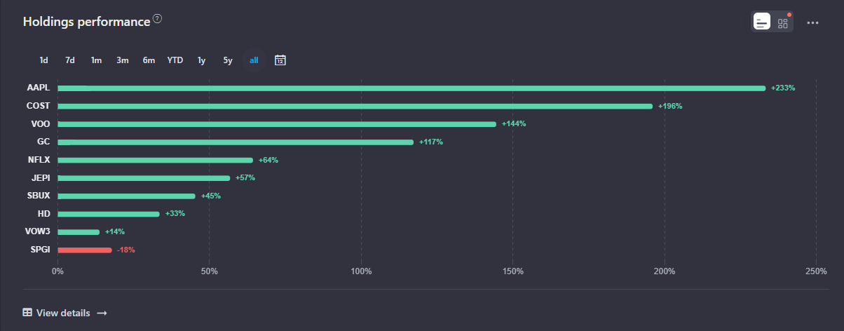
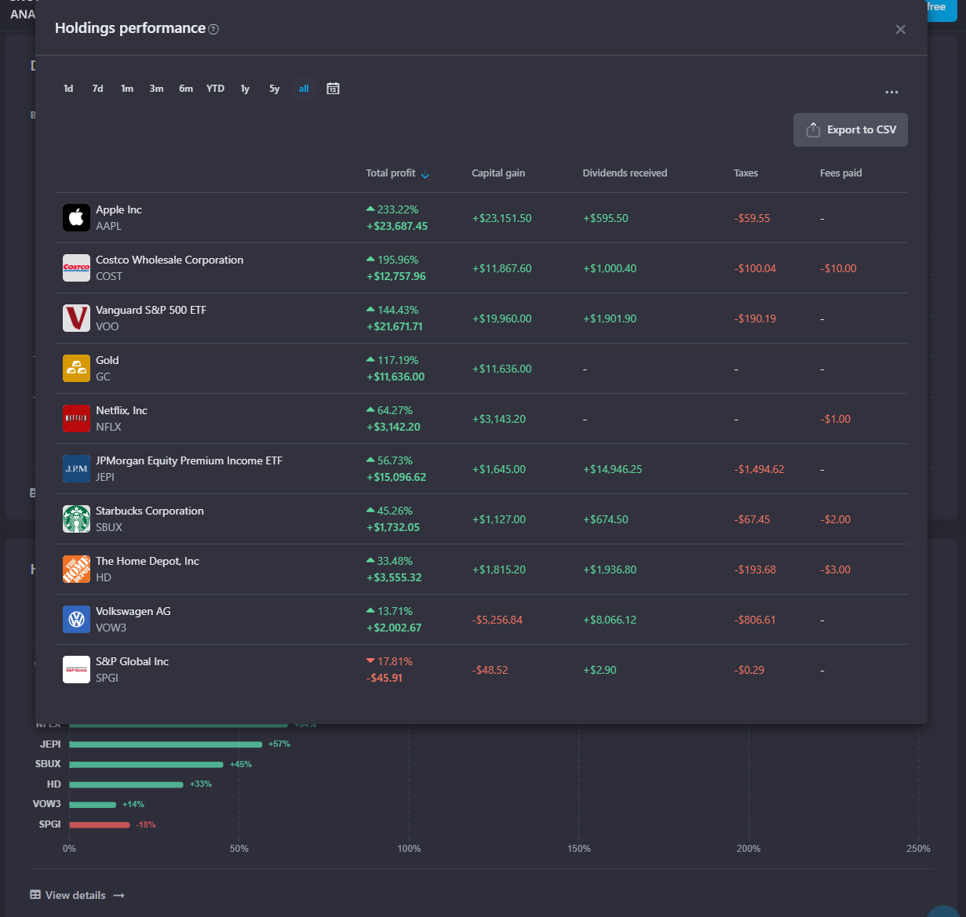

Dividend Calendar: could be refitted for other use (e.g. events calendar, earnings calendar, etc.).
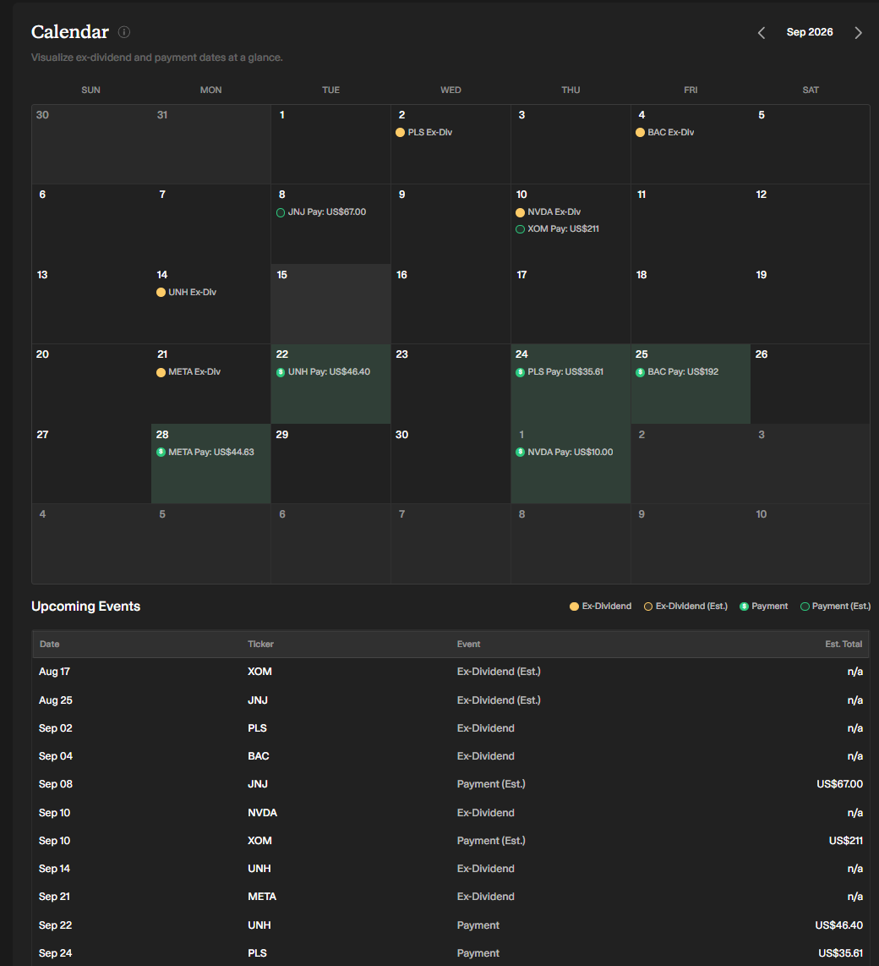
Optional: Metrics:
